**Lightning Inc.’s Future Expansion Plan**

**Objective of the Study:**

The purpose of this study is to find the top three most profitable states in the United States for the expansion of fiber-optics services for Lightning Inc. It is important to use data visualization for this study as visual data makes it easier for readers to interpret vital information from the massive dataset.

**Analysis:**

The top three states where our company should expand its services are California, Texas, and Florida to increase profitability.

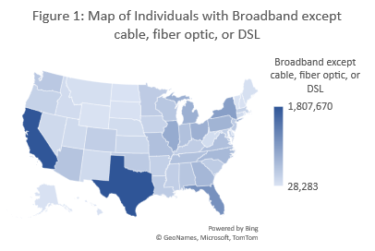The factors influencing the decision-making process with regard to company expansion are the types of internet services used by the target customers, the types of computers used by the target customers, and their household income range.

**Types of Internet Services:** As observed in Figure 1, Texas has the highest number of individuals with broadband except cable, fiber optics, or DSL followed by California and Florida.

Figure 2 represents a bar chart with the number of individuals with broadband except cable, fiber optics, or DSL in the top 5 states in descending order to clarify the minor differences between data values.

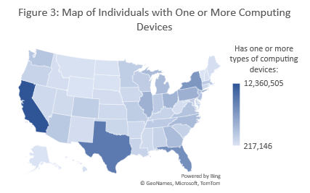

**Types of Computers:** It is evident in Figure 3 that California has the highest number of individuals with one or more computing devices followed by Texas and Florida.

Figure 4 represents a bar chart with the number of individuals with one or more computing devices in the top 5 states in descending order to clarify the minor differences between data values.

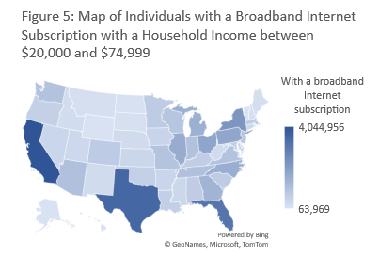

**Income levels:** As seen in Figure 5, California has the highest household income between $20,000 and $74,999 followed by Texas and Florida.

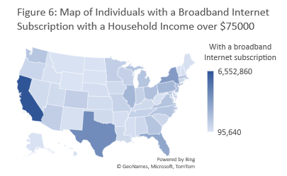

Based on Figure 6, California again has the highest household income over $75,000 followed by Texas and New York.



Figure 7 represents a bar chart with the number of individuals with a broadband internet subscription earning over $75,000 in the top 5 states in descending order to clarify the minor differences between data values.

**Conclusion:**

The top three states in three out of the four visualizations include California, Texas, and Florida. In Figure 4, Florida ranks in fourth place. However, the difference between New York and Florida is marginal and Florida outperforms New York by a larger margin in the other categories.

While considering the types of internet services used by individuals across the US, the data was modified by excluding the individuals who have cable, fiber optics, or DSL to narrow the scope of study to individuals having a regular broadband internet connection.

Overall, we can rank California as the no.1 state for expansion of fiber-optics although Texas ranks no.1 in broadband except fiber optics as California ranks no.1 in both income level of the target population and number of devices owned. Texas ranks no.2 followed by Florida at no.3.